Name of the Student: G. Manasa | Academic Year: 2024 – 2028
Student Registration Number: 241U1R3007 | Year & Term: II & I
Study Level: UG | Class & Section: CSE – DS
Name of the Course: Probability & Statistics | Name of the Instructor:
Name of the Assessment: Group Activity Report | Date of Submission: 31-08-2025

Group Activity Report
2-Day Training Program on R Programming
We had a 2-day training program on R Programming as part of our Probability and Statistics course.
On the first day, Pavan sir introduced R programming. He explained what R is, its uses, and the difference between R and Excel for doing calculations.
On the second day, Swetha Sree ma’am took the session. She first guided us on how to install R software as many students faced issues. After that, she taught us the basics like defining variables, writing simple programs (addition, subtraction, product, square root, etc.), and creating vectors using c(). She also showed how to use the help function in R.
We then learned about plotting in R using the plot() function. By changing the type, we can draw scatter plots, line graphs, step plots, etc. We also learned how to add titles and labels for x-axis and y-axis.
Next, mam explained basic statistics like mean, variance, and standard deviation using mean(), var(), and sd(). She also showed how to create frequency distributions using rep().
In probability, we used sample() to simulate coin tosses and dice throws. We practiced union, intersection, and conditional probability in R.
We also studied distributions:
- Binomial distribution using dbinom(), pbinom(), rbinom() (example: tossing coins).
- Poisson distribution using dpois(), ppois(), rpois() (example: hospital calls).
- Normal distribution using dnorm(), pnorm(), qnorm(), rnorm(). We even plotted a bell curve which made it more clear.

Questions:
Question 1
Draw contingency table for Person Child, Young, Elder and Toy Small, Medium, Large based on the 150 observations.
Input:
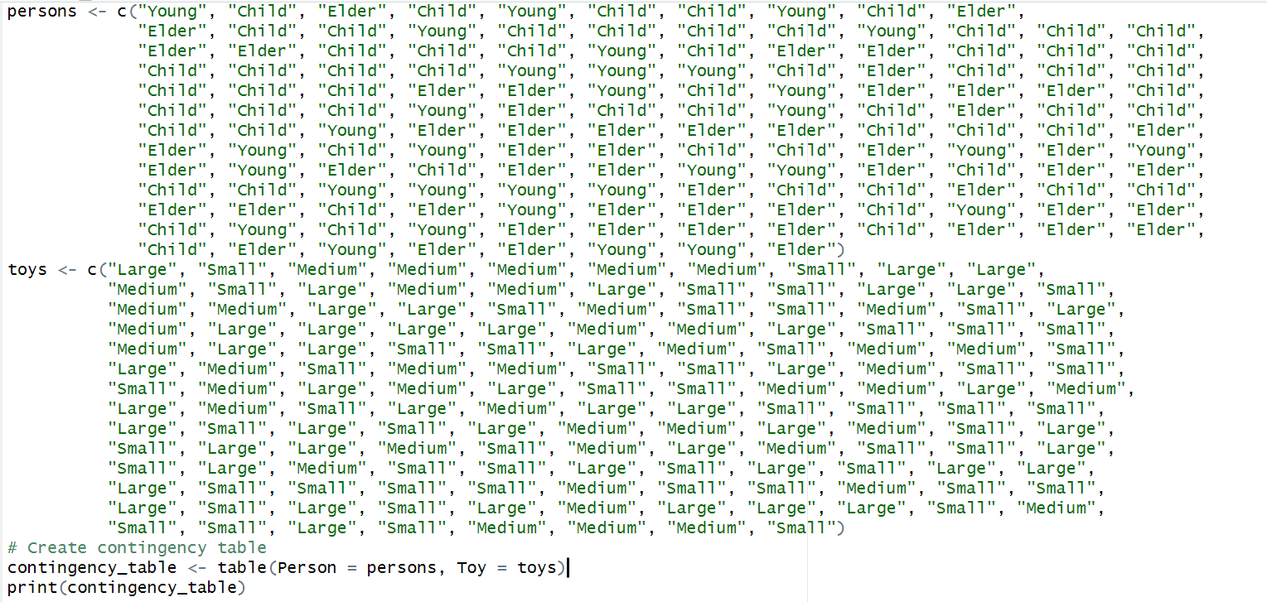

Output:
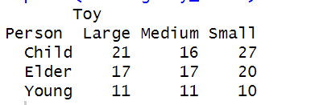

Question 2
Given 150 cars petrol consumption and distance covered, find covariance and correlation between them.
Input:
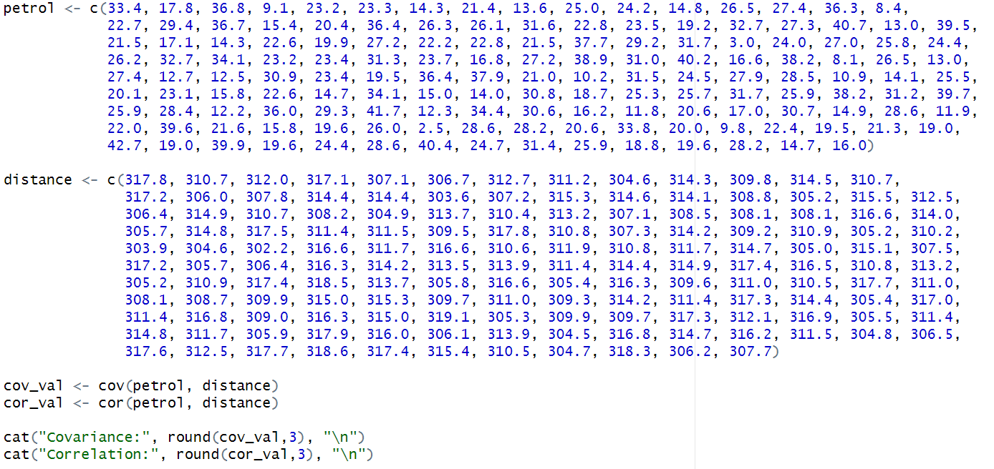
Output:
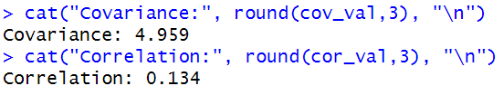
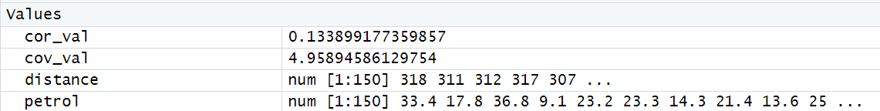

Question 3
Test the mayor's claim that the average carpet area of 25 flats is 525 sq. ft. Use 5% significance level.
Input:
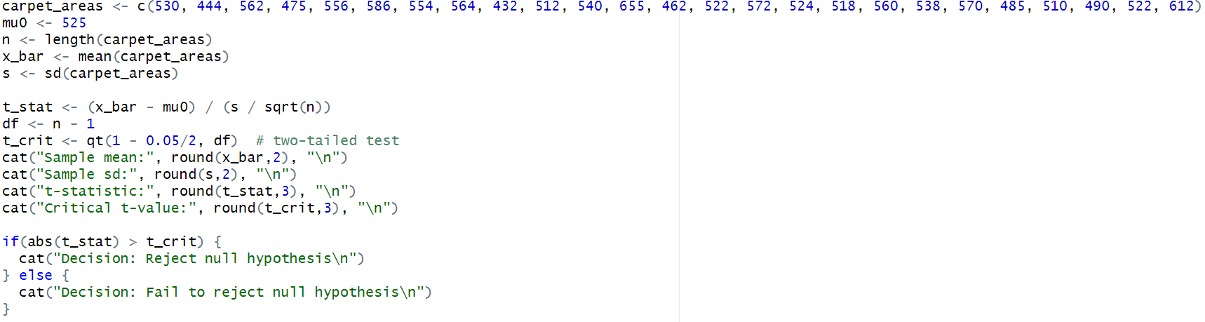

Output:
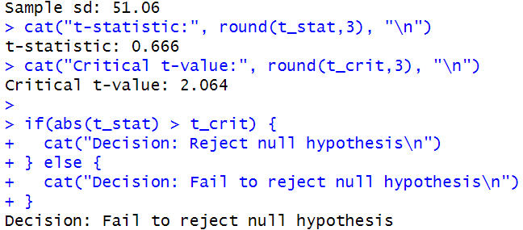
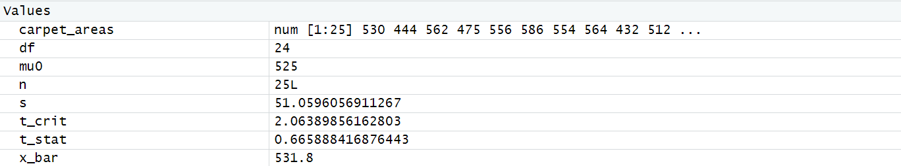

Question 4
Assume that 50% of all engineering students are good in Mathematics. Determine the probabilities that among 18 engineering students.
- Exactly 10
- At least 10
- At most 8
- Atleast 2 and at most 9 are good in mathematics
Input:
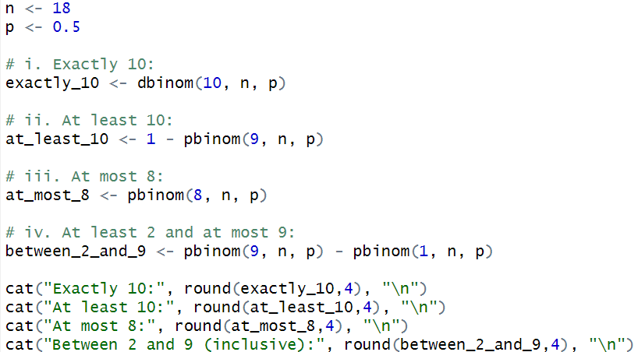
Output:
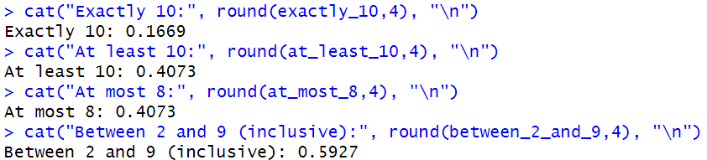
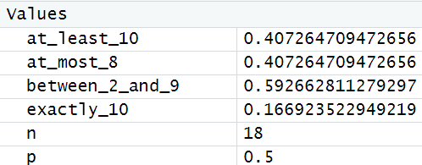

Question 5
If 2% of light bulbs are defective, find the probability if
- At least one is defective
- Exactly 7 are defective
- P (1 < X < 8) in sample of 100

Input:
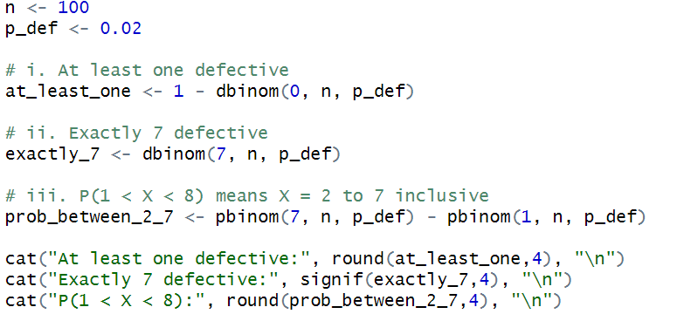

Output:
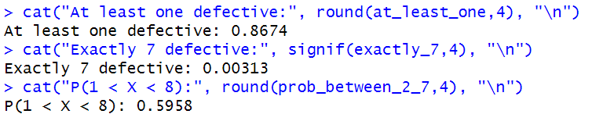
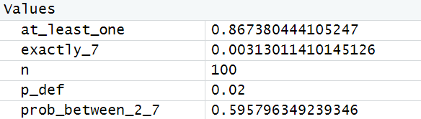

Question 6
1000 students wrote an exam. Mean = 35, SD = 5. Assuming normality, find:
i. No. of students with marks between 25 and 40
ii. No. of students scoring more than 40
iii. No. of students scoring below 20
iv. No. of students scoring more than 50

Input:
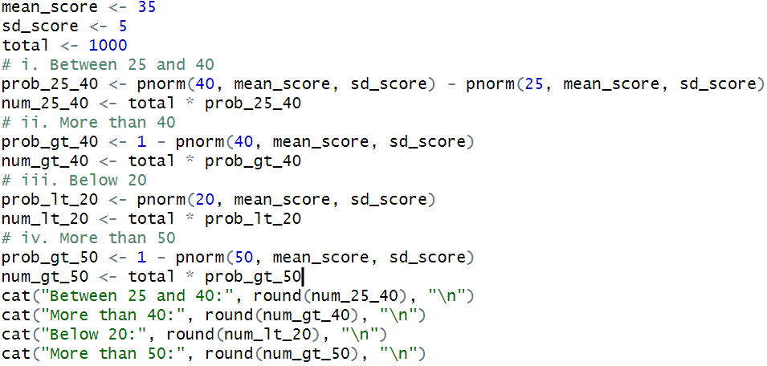

Output:
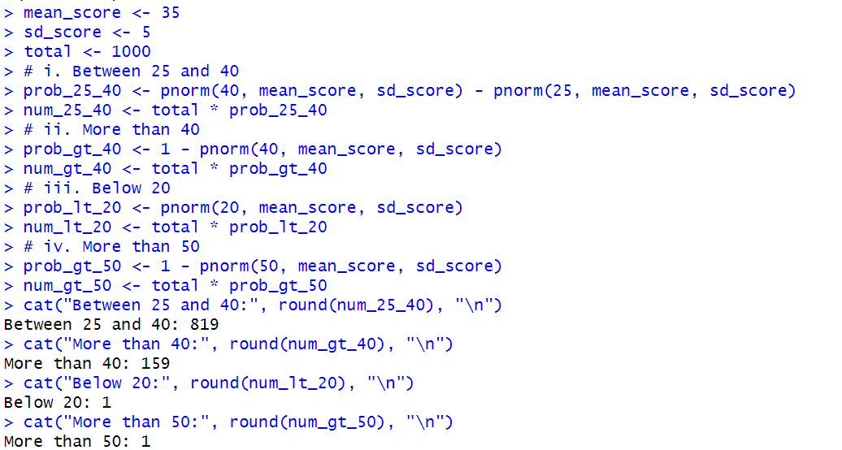
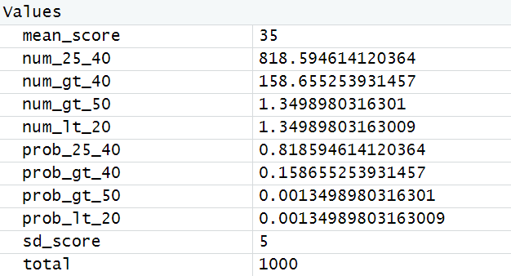

Question 7
A random sample of 10 bags of pesticide are taken whose weights are 50, 49, 52, 44, 45, 48, 46, 45, 49, 45 (in kgs). Test whether the average packing can be taken to be 50 kgs.

Input:
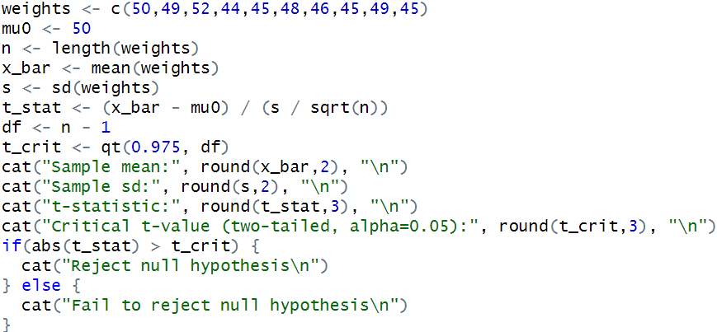
Output:
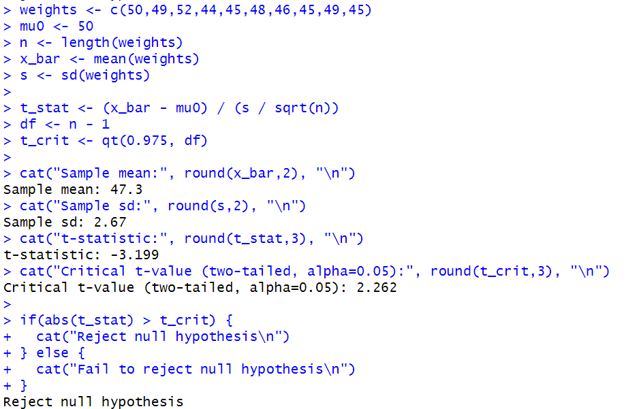
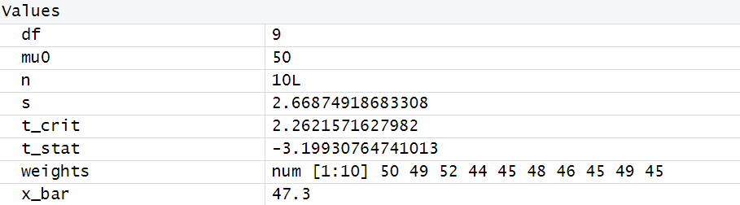

Question 8:
Two horses A and B were tested according to the time (in seconds) to run a particular tract with the following results.
Horse A | 28 | 30 | 32 | 33 | 33 | 29 | 34
Horse B | 29 | 30 | 30 | 24 | 27 | 29
Input:
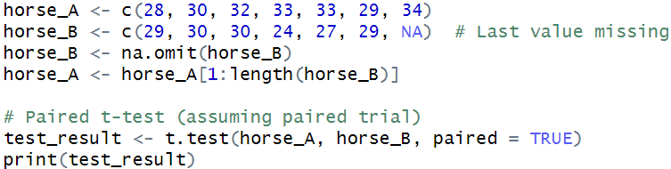
Output:
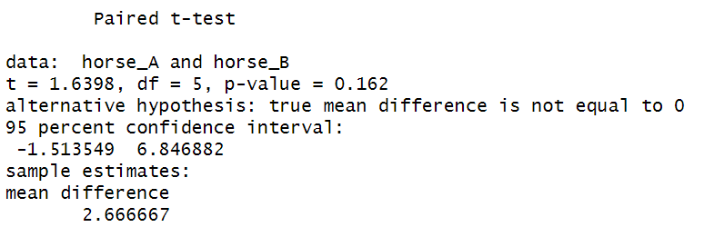
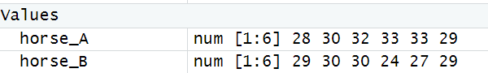

Question 9
Scores obtained in a shooting competition by 10 soldiers before and after intensive training are given below:
Before | 67 | 24 | 57 | 55 | 63 | 54 | 56 | 68 | 33 | 43
After | 70 | 38 | 58 | 58 | 56 | 67 | 68 | 75 | 42 | 38
Input:
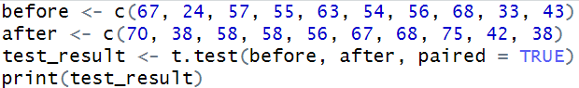

Output:
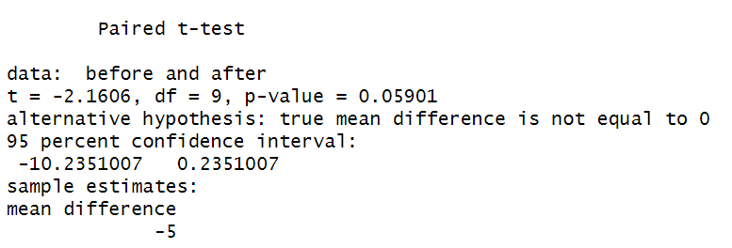
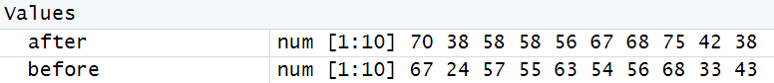

Question 10
The nicotine contents in milligrams in two samples of tobacco were found to be as follows:
Sample A | 24 | 27 | 26 | 21 | 25 | -
Sample B | 27 | 30 | 28 | 31 | 22 | 36
Input:
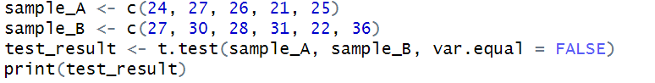
Output:
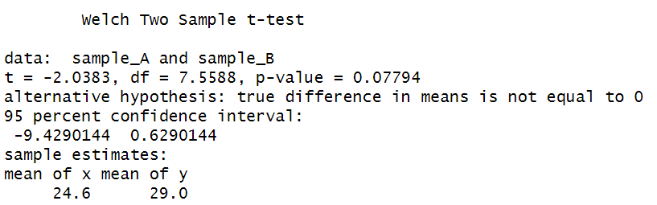
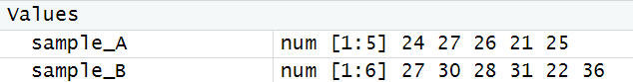
Question 11
Calculate the regression equations of Y on X from the data given below, taking deviations from actual means of X and Y.
Price | 10 | 12 | 13 | 12 | 16 | 15
Amount Demanded | 40 | 38 | 43 | 45 | 37 | 43

Input:
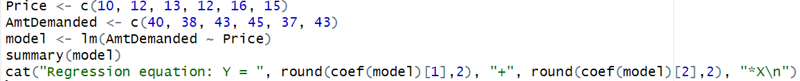
Output:
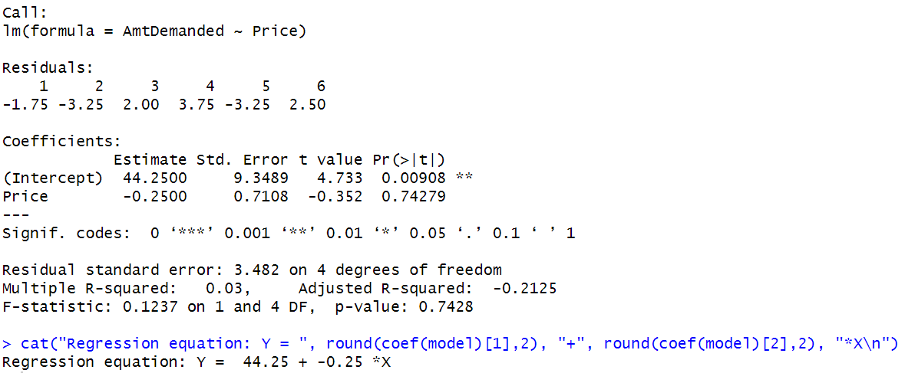
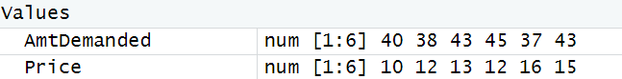

Question 12
Datasets for Linear Regression
- airquality
- BOD (Bio chemical oxygen demand)
- cars
- ChickWeight
- mdeaths (Monthly Deaths from Lung Diseases in the UK)
- infert (Infertility after Spontaneous and Induced Abortion)
- trees (Diameter, Height and Volume for Black Cherry Trees)

Input:
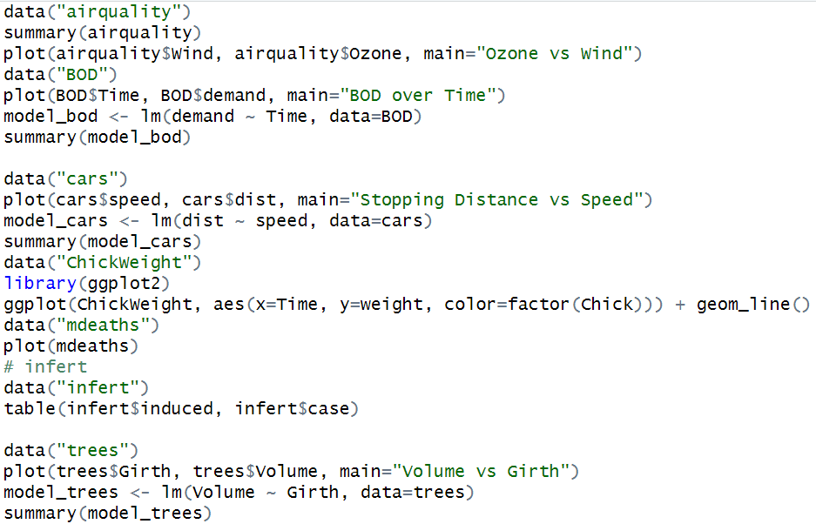
Output:
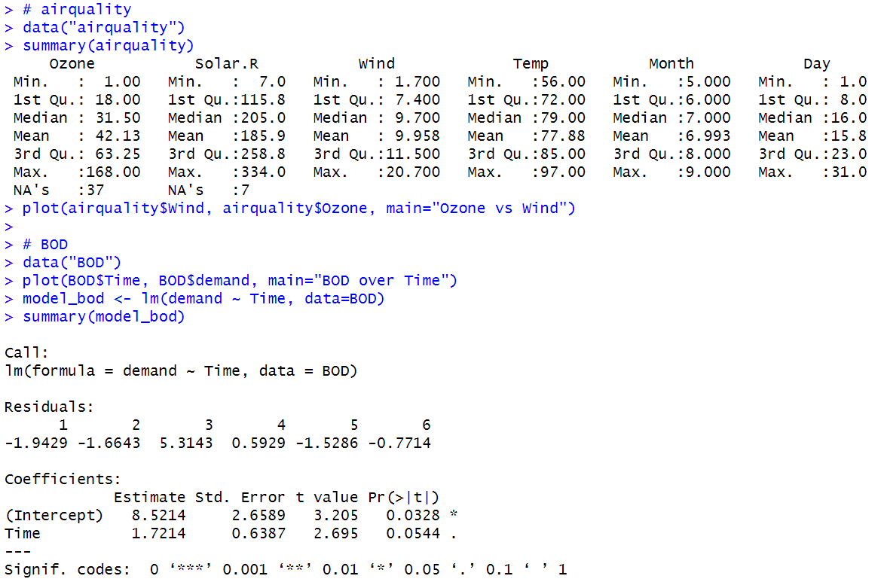
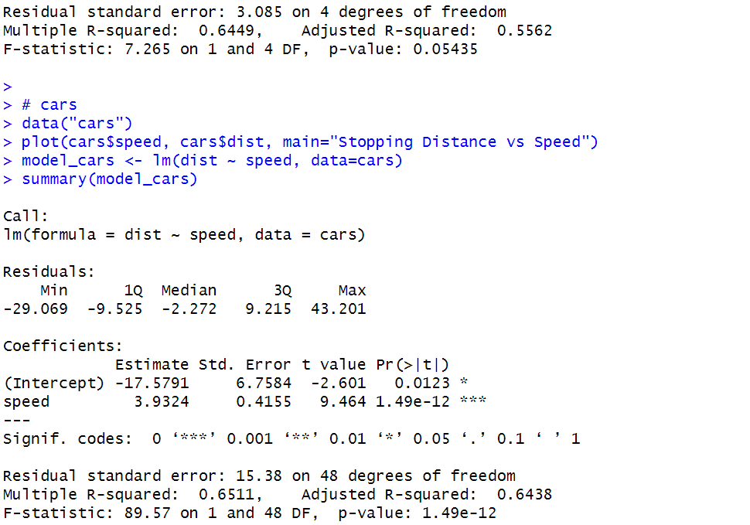
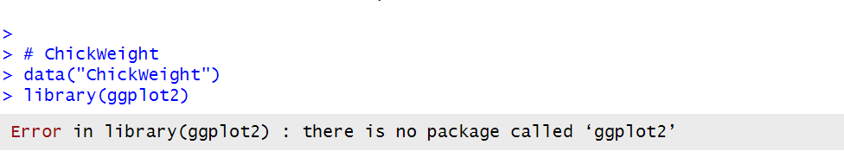
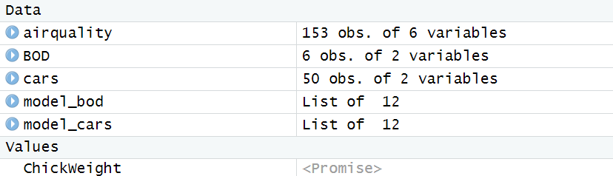

Plot:
